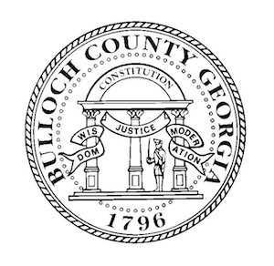
Request for Recognition

Bulloch County would not be a successful community or place to work if it weren’t for the hard work of the employees. The Commissioners would like to recognize those who go above and beyond to better Bulloch County. Please complete this form to request public recognition by the Board of Commissioners for an employee in your department that has reached a career milestone. Examples include certifications, awards, heroic actions, etc. Be as detailed as possible.

Name of Person(s) to be Recognized: _____________________________________________________

Title: __________________________________ Department: _______________________________

Accomplishment to be Recognized:
____________________________________________________________________________________

How does this benefit Bulloch County?
____________________________________________________________________________________

____________________________________________________________________________________

Employees will be recognized publicly at a Board of Commissioners Meeting. Please ensure that they can be present at the requested meeting.

Requested Commissioner’s Meeting Date: _________________________________________________

Your Name: _____________________________ Title: ____________________________________

Department Head Signature: ____________________________________________________________

Requests must be submitted two weeks in advance of the proposed meeting date.
Please attach supporting documents such as certificates of completion.
------------------------------------------------------------------------------------------------------------------------------
For Clerk Use Only

Approve: _____ Deny: _____ Meeting Date: _______

Comments: __________________________________________________________________________
__________________________________________________________________________

